Progress Note Single Service CalAIM 2022-07 Changes to note – Clinicians Gateway 2022 July

- The billing header remains the same
- The instructions have been updated
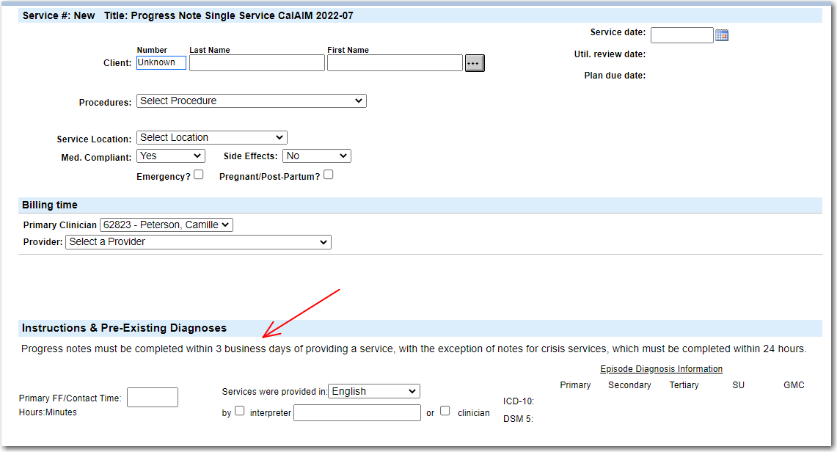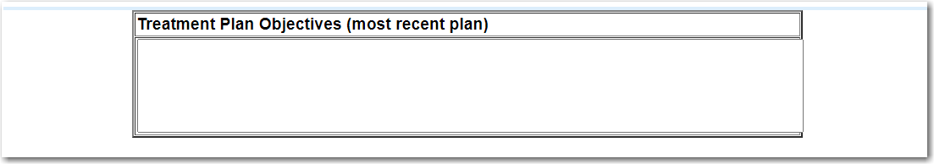

- The text boxes have been reduced from five to three, with one appropriate for group services.
  - Narrative is required
  - Co-staff is for groups (so optional at other times)
  - Next Steps is required
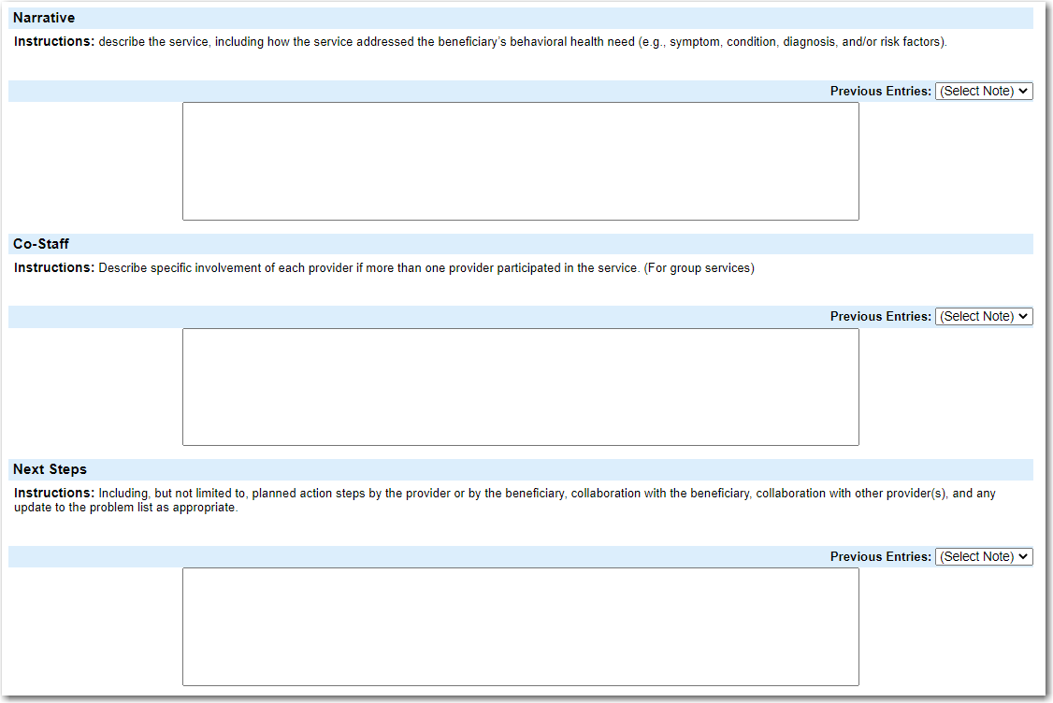
- The documentation time log remains the same
